**Required formatting**

* *File Type:* The manuscript must be submitted as an editable .doc or .docx file.
* *Font:* 12 pt, Calibri.
* *Line spacing:* Include single-line spaces between all paragraphs, headings, steps, *etc.*
* *Page margins:* 1 inch (2.54 cm) on all sides.
* *Page size:* Standard US Letter.

***Technical Language***

* The manuscript text must be **original, in complete sentences, and in paragraph form**.
* Define acronyms/abbreviations upon first use in the main text.
* Use SI abbreviations for all units: L, mL, µL, h, min, s, *etc.*
* Italicize all Latin words and nomenclature: *et al., in vivo, in vitro, in silico, i.e., e.g., etc.*
* Include a space between all numbers and the corresponding unit: 50 mg, 100 mL, 37 °C, *etc.*
* List all centrifugation speeds in terms of centrifugal g-force instead of rpm: 100 x g
* Molecular formulas should include subscripts: CO2, H2O2, O2, *etc.*
* Abbreviate species names after first use: *Caenorhabditis elegans* should be *C. elegans.*

**TITLE:** *(150 characters maximum)*

**The title should represent the content included in the video** and include the model system used or the type of study design. Please avoid the use of abbreviations.

An open-source EEGLAB plugin for jointly analyzing EEG and cardiovascular signals.

**AUTHORS AND AFFILIATIONS:**

Cedric Cannard1,2, Helane Wahbeh2, Arnaud Delorme1,2,3

1Centre de Recherche Cerveau et Cognition (CerCo), CNRS, Toulouse III University, France

2Institute of Noetic Sciences (IONS), Novato, California, USA.

3Swartz Center of Computational Neuroscience (SCCN), INC, UCSD, La Jolla, USA

Corresponding Author:

Cedric Cannard

ccannard@noetic.org

Tel: (510)-326-1734

Email Addresses of Co-authors**:**

Helane Wahbeh hwahbeh@noetic.org

Arnaud Delorme adelorme@ucsd.edu

**KEYWORDS:** *(6 minimum, 12 maximum)*

EEGLAB, EEG, ECG, PPG, HRV, joint analysis, feature-based, event-related

**SUMMARY:** *(10-word minimum, 50-word maximum)*

The summary should clearly state the goal of the protocol. It may include a general description of the method and its applications. This description should focus on the protocol, not the results obtained by the method.

Enter text here.

**ABSTRACT:** *(150-word minimum, 300-word maximum)*

The abstract should focus on the method being presented rather than the results of a specific experiment. Include a statement about the purpose of the method. A more detailed overview of the method and a summary of its advantages, limitations, and applications is appropriate. Please focus on the general types of results acquired. Do not include references here.

We present an open-source toolbox for processing and analyzing joint electroencephalography (EEG) and electrocardiography/photoplethysmography (ECG/PPG) signals. EEG and ECG/PPG are non-invasive, low-cost, and highly mobile techniques for monitoring brain and cardiovascular activity. They offer distinct advantages over other neuroimaging methods such as magnetoencephalography (MEG), functional magnetic resonance imaging (fMRI) and positron emission tomography (PET) in terms of their lower cost, portability, and ability to collect data in real-world settings. The interaction between the cortical and cardiovascular systems has been the subject of increasing interest, as it can capture useful information about the coupling of brain and cardiovascular function. However, analyzing the interaction between these time series can be challenging due to the complex or noisy nature of the data and the lack of standardized analysis methods. Existing tools for jointly analyzing these biosignals often require a high level of technical expertise and may not provide all of the necessary features for studying the interaction between these signals. Moreover, many existing tools are not open-source limiting their accessibility, and a consensus towards clear signal processing guidelines is still in development, and reproducibility. The proposed toolbox addresses these limitations by providing a comprehensive set of signal processing functions, implementing latest guidelines as its default parameters, and three main functions: 1) feature-based for continuous data for assessing associations between various features extracted from EEG and HRV signals (time, frequency, and nonlinear features); 2) event-related for epoched data (EEG-ECG coherence, heartbeat-evoked potentials in time, frequency, and time-frequency domains); 3) EEG signal processing (extracts heart components from EEG signals using ICA). Robust statistics are implemented for assessing relationships between these times series at the individual level (e.g., permutation statistics, corrections for type 1 error). Linear and nonlinear features are provided to better capture complex, bidirectional interactions between that take place between the cardiovascular, subcortical, and cortical systems. Additionally, the toolbox can be used simply for extracting heart components from the EEG data using independent component analysis (ICA). This open-source toolbox should provide a valuable resource for researchers and clinicians interested in studying the relationship between brain and cardiovascular activity and can be easily adapted and extended to meet specific research needs.

**INTRODUCTION:** *(150-word minimum, 1500-word maximum, 2-paragraph minimum)*

This section should include:

* A clear statement of the purpose of this method
* The rationale behind the development and/or use of this method
* The advantages over alternative methods with references to relevant studies
* The context of the method in the wider body of published literature
* Information to help readers decide whether the method described is appropriate for them
* Purpose of this method

The purpose of this method is to ease the investigation of relationships between the brain and the heart, by facilitating the joint analysis of electroencephalography (EEG) and cardiovascular signals, namely electrocardiography (ECG) and photoplethysmography (PPG), while implanting latest guidelines from experts in this field. This tool addresses limitations from existing tools and is made open source to facilitate accessibility and reproducibility in the field. The proposed toolbox should serve as a valuable resource for researchers and clinicians interested in removing cardiac artifacts from EEG signals, in extracting features from EEG and ECG/PPG signals, or in studying the relationship between brain and cardiovascular activity. Ultimately, this toolbox aims to pave the way for more in-depth investigations into the complex interplay between the brain and heart systems.

* The rationale behind the development and/or use of this method + context of the method in the wider body of published literature

**Reductionist vs multimodal approaches**

For a long time, the reductionist approach has dominated scientific inquiry in the field of human physiology and cognition. This approach involved dissecting complex bodily and mental processes into smaller, more manageable components, allowing researchers to focus on individual systems in isolation. This strategy arose due to the immense challenge of studying the intricate and interconnected nature of the human body and mind (von Bertalanffy, 1968). Reductionism has been instrumental in understanding individual subsystems in isolation, such as elucidating the role of ion channels and action potentials for neural (Hodgkin & Huxley, 1952) and cardiac (Bean et al., 1984) communication. However, a large gap remains in our understanding of how these isolated systems interact together on a larger spatial and temporal scale. Thanks to recent advances in technology, a more integrative approach is now gaining interest. Innovations in hardware, signal processing, data storage, and computing capabilities have enabled researchers to collect and analyze electrophysiological signals from different bodily systems simultaneously (e.g., heart, brain, skin, etc.; Jiang et al. 2019; Insel et al., 2017; Kappenman & Luck, 2010). This integrative – or multimodal – approach will pave the way for a more comprehensive understanding of human physiology, cognition, pathology, and consciousness (Bunge, 2003; Fuchs, 2018; Thayer & Lane, 2009). Consequently, this multimodal approach is now considered an essential component of modern research, complementing traditional reductionist methods, and offering novel insights into the synergistic mechanisms governing the human body and mind.

**Heart-brain research with fMRI and PET**

Studying the intricate relationship between the brain and the heart can yield valuable insights into the underlying physiology and anatomy of the human body, ultimately leading to the development of novel diagnostic and therapeutic tools. The relationship between the heart and the brain has been studied via neuroimaging methods such as functional magnetic resonance imaging (fMRI) and positron emission tomography (PET). Using these tools, researchers highlighted some brain regions associated with cardiovascular control (e.g., manipulation of heart rate and blood pressure; Critchley 2000; Napadow 2008), showed the influence of heart rate on the BOLD signal (Chang et al., 2009; Shmueli 2007), or identified potential brain-body pathways contributing to coronary heart disease (i.e., stress-evoked blood pressure; Gianaros 2009).

**Brief description of EEG, ECG, PPG and why they are better**

While these studies have significantly advanced our understanding of the complex interplay between the central nervous system (CNS) and cardiovascular function, these neuroimaging techniques are expensive, have limited availability, and are confined to controlled laboratory settings, which restricts their practicality for real-world and large-scale applications. In contrast, EEG and ECG/PPG are more affordable and portable tools that offer the potential for studying brain-heart interactions in more diverse settings and populations, or over longer periods of time, providing new opportunities for investigating the dynamic relationship between brain and heart function. ECG measures the electrical signals generated by the heart when it contracts and relaxes via placement of electrodes on the skin (usually on the chest, arms, or legs). PPG measures blood volume changes in the microvascular tissues by using a light source (e.g., LED) and a photodetector placed on the skin (commonly on a fingertip, earlobe, or forehead). Since blood absorbs more light than the surrounding tissue, the PPG signal can be used to estimate blood flow and pulse rate. Both methods provide valuable information about cardiovascular function, but they serve different purposes and offer distinct types of data. As such, the use of EEG and ECG/PPG holds great promise for advancing our understanding of the physiological, cognitive, and emotional processes underlying brain-heart interactions and their implications for human health and well-being. Similar to ECG, EEG records the electrical fields generated by synchronized activity of thousands of cortical neurons, by placing electrodes on the scalp.

**The 2 approaches to jointly analyze EEG and cardiovascular signals**

There are two main approaches to examine interactions between EEG and cardiovascular signals:

1. Event-related: each heartbeat is marked in the EEG time series to examine with high temporal accuracy the cortical activity processing cardiac signals (Schandry 1981; Pollatos 2005; Montoya 1993; Park & Tallon-Baudry 2014; Couto 2015; Jiang et al. 2019; Dirlich et al., 1998). This method is termed heartbeat-evoked potentials (HEP) and is similar to traditional event-related potential (ERP) studies, required the two time series to be time-locked, but the events are heartbeats as opposed to stimuli.
2. Feature-based: using continuous data, this approach extracts features from the EEG signals and from the cardiovascular signals and examine associations between them. Cardiovascular features are typically heart-rate variability (HRV) measures in the time, frequency, or nonlinear domains. This has been done with ECG (Thayer et al. 2012; Mather 2018; Kemp 2013) and PPG to a lesser extent (Khosrow-Khavar 2014). This approach provides trait information that can be used for making medical forecasting or classification (e.g., mental or physical health) and finding more general associations, relative to HEP that focuses on mechanisms at millisecond accuracy.

The advantages over alternative methods with references to relevant studies

While some tools exist to process cardiovascular and EEG (e.g., EEGLAB, Fieldtrip, Brainstorm) signals separately, none is currently available for jointly analyzing them. Furthermore, the tools available to process cardiovascular signals:

* require expensive license purchase and do not allow processing large datasets in batch via command line (Kubios);
* or require advanced programming skills by not providing a graphical user interface (GUI; Physionet Cardiovascular Signal toolbox; [Vest et al. 2019](https://www.ncbi.nlm.nih.gov/pmc/articles/PMC6442742/pdf/nihms-1509712.pdf)).

To our knowledge, three open-source MATLAB toolboxes exist to support ECG processing (R peaks detection) and HEP analysis with a GUI. The ecg-kit ([REF](https://github.com/marianux/ecg-kit)), the HEPLAB EEGLAB plugin ([REF](https://github.com/perakakis/HEPLAB)), and the CARE-rCortex EEGLAB plugin ([Grosselin et al. 2018](https://www.sciencedirect.com/science/article/abs/pii/S0165027018302474)). The CARE-rCortex is the most advanced, providing an easy-to-use GUI, analysis of both ECG and respiratory signals, time-frequency domain analysis, and advanced statistics. However, it still requires expertise from the user to recognize and remove artifactual R peaks, correction for multiple comparison is done using the Bonferroni method (which is too conservative for EEG analysis), it does not offer command line access for processing and analyzing large datasets, and most importantly, it only supports time-locked analysis (HEP) and no feature-based analysis.

To address these limitations, this article presents a new open-source MATLAB toolbox, named “BrainBeats”, implemented as an EEGLAB plugin designed to jointly process and analyze EEG and ECG/PPG signals. It incorporates the following advantages over previous methods:

* Easy-to-use GUI (for non-programmers) and command line mode (for programmers aiming to perform automated processing and analysis on large datasets).
* Implements the validated algorithms from the Physionet Cardiovascular Signal toolbox ([Vest et al. 2019](https://www.ncbi.nlm.nih.gov/pmc/articles/PMC6442742/pdf/nihms-1509712.pdf)) for detecting the R peaks, estimating the signal quality index (SQI) of the RR time series, and removing or interpolating the RR artifacts.
* Implements validated EEG signal processing including referencing (to infinity for montages with at least 30; Yao [2001](https://pubmed.ncbi.nlm.nih.gov/11761077/), [200](https://pubmed.ncbi.nlm.nih.gov/15798293/)5; [2017](https://www.ncbi.nlm.nih.gov/pmc/articles/PMC5331115/); [Dong 2017](https://www.ncbi.nlm.nih.gov/pmc/articles/PMC5670162/)), detection and interpolation of bad channels, detection and interpolation of EEG artifacts (Mullen 2015; Delorme 2004; 2023; Pion-Tonachini 2019).
* Supports HEP analysis in both time and time-frequency domains (EEGLAB STUDY mode) and advanced statistics using hierarchical linear modeling provided by the LIMO-EEG plugins (Pernet 2011). This statistical approach accounts well for within and between- subjects variance, downweighs trials with artifacts using weighted least square (WLS; Pernet 2022) optimization and applies bootstrap statistics and advanced corrections for multiple comparisons (e.g., spatiotemporal cluster correction). Furthermore, EEG-ECG coherence can be calculated for each trial and compared across conditions.
* Supports for the first time the study of brain-heart associations using a feature-based approach. HRV features (listed in **Figure 1**) are calculated following guidelines to facilitate standardized and accurate analysis (see below for which guidelines are implemented depending on the features).

This approach captures the trait variable and can be used on continuous data collected with low-cost wearable headsets in real-world settings. These features can be analyzed simply with correlation procedures, or machine learning to make classifications and predictions (e.g., detection of depression before symptoms are too advanced; REFS).

* Provides the option to simply use the ECG signals for automatically extracting heart artifacts from EEG signals, using the ICLabel EEGLAB plugin.
* Provides data visualization to inspect signals (raw, RR intervals, EEG and RR artifacts that have been removed or interpolated, HEP data, power spectra, etc.; see **Figures 2 and 3**).

Information to help readers decide whether the method described is appropriate for them

This toolbox is appropriate for any researcher or clinician that possesses data containing EEG and ECG/PPG signals. The plugin does not support the importation of EEG and ECG/PPG signals from separate files yet (although this feature will be available soon). The toolbox can be used for simply removing heart artifacts from EEG signals with high confidence, to simply extract EEG or HRV features (for other purposes), or for assessing interactions between these two systems.

**PROTOCOL:** *(1-page minimum, 10-page maximum)*

**The protocol text should provide a detailed description to enable the accurate replication of the presented method (including setup, materials, actions, conditions, *etc.*) by both experts and researchers new to the field.** Well-established methods (*e.g.*, Western Blotting, PCR, *etc.*) used within the protocol should be cited as necessary and any modification of the aforementioned procedures should be described.

**A) Format:**

* The protocol must be a numbered list: step 1 followed by 1.1, followed by 1.1.1, *etc*.
* Include a space between each numbered step or note in the protocol.
* Each step should include 1-2 actions and contain 2-3 sentences. Use sub-steps as necessary.
* Please do not use indentations.
* Do not underline any text in the protocol; however, **bold** text is acceptable for emphasis.

**B) Grammar:**

* Use complete sentences throughout the protocol.
* Avoid the use of personal pronouns or colloquial phrases (*e.g.*, I, you, your, we, our).
* Use the active/imperative voice throughout this section.

Good Example: Add 30 µL of solution A to 30 µL of solution B.

Bad Example: 30 µL of solution A was added to 30 µL of solution B.

* Avoid the use of commercial language, including ™/®/© symbols or company brand names before/after an instrument or reagent. Cite these in the Table of Materials instead.

**C) Technical Specifications:**

* Use subheadings for clarity if there are discrete stages in the protocol.
* Please indicate any points at which the experiment can be paused and then restarted later. For these situations, indicate the choices at that point in the protocol.

Example: Incubate the filter for 4 h at room temperature or overnight at 4 °C.

* Indicate any toxic or harmful chemicals with the word “CAUTION” when they are first used, and include notes that describe the hazard and the appropriate handling guidelines.
* All methods that involve the use of human or animal subjects and/or tissue or field sampling must include an ethics statement before the numbered protocol section (see Editorial Policies: ([www.jove.com/author/editorial-policies](http://www.jove.com/author/editorial-policies)) for more information).

Example: All methods described here have been approved by the Institutional Animal Care and Use Committee (IACUC) of Harvard University.

D) Protocol Length:

There is a 10-page limit (with proper formatting) for the amount of text written in the protocol section. There is a 2.75-page limit on the amount of content we can film for a single video article.

* **For a Protocol section that exceeds 3 pages, highlight in yellow up to 2.75 pages (no less than 1 page) of protocol text (including headers and spacing) to be featured in the video. Our scriptwriters will derive the video script directly from the highlighted text.**
  + - Bear in mind the goal of the protocol, and highlight the critical steps to be filmed.
    - Please ensure that the highlighted steps form a cohesive narrative with a logical flow from one highlighted step to the next. The highlighted part of the step must include at least one action that is written in the imperative voice.
    - You do not need to delete steps from the protocol. The full-length manuscript will be published along with the video. All un-filmed steps will still be available in the written manuscript for readers.

**E) Equations**:(Example of JoVE video with equations: [www.jove.com/51288](http://www.jove.com/51288))

* Ensure all inline equations are formatted identically, using the consistent font style.
* Separate each equation to its own line, and define all terms in the equation. A 4-line equation should take up 4x the vertical space as a single line equation.
* Do not embed equations as images. Instead, use the equation builder in MS Word.

**F) Example Protocol:**

1. **Deactivation of Basic Alumina** 
   1. To generate basic alumina (activity IV), add 100 g of basic alumina (activity I) to a 500-mL round bottom flask.
      1. Add 10 mL of water to the flask and fit it with a glass stopper.
      2. Shake the flask vigorously until no lumps are visible, indicating even spreading of water throughout the alumina. Allow the alumina to cool to room temperature (RT).

CAUTION: Adsorption of water is exothermic, and the flask may get hot, which may result in a buildup of pressure. Release any pressure buildup frequently.

1. **Purification of the Iodoaziridine**
   1. Purify the crude iodoaziridine by column chromatography using basic alumina (activity IV) as the stationary phase, eluting with hexane and grading to 5% EtOAc/hexane7.

Note: High concentrations of EtOAc should not be used with basic alumina. In these cases, diethyl ether can be used instead.

* 1. Combine the product-containing fractions, and remove the solvent under reduced pressure to obtain the pure iodoaziridine.

Note: The protocol can be paused here.

Enter text here (10-page maximum, 2.75 pages of highlighted text for filming).

**METHOD 1: Remove heart components from EEG signals**

1.1. Load the 1st sample dataset containing both 3 EEG channels and one ECG channel into EEGLAB: File > Load existing dataset > select “sample_data1.set” > Open. Note: You may need to install other EEGLAB plugins to import your dataset depending on the file format (e.g., .bdf, .edf, .vhdr, etc.).

1.2. Select parameters: Tools > Run BrainBeats (see **Figure 1**). The general user interface (GUI) pops up (**Figure 2**).

1.3. Select analysis type as “Remove heart components from EEG signals”, “ECG” heart data type, the name of the ECG channel “ECG” from the list of channels, and “No (already processed)” as this sample file was already preprocessed. Note: The “Plot outputs” option is set by default. Click “Ok” to launch.

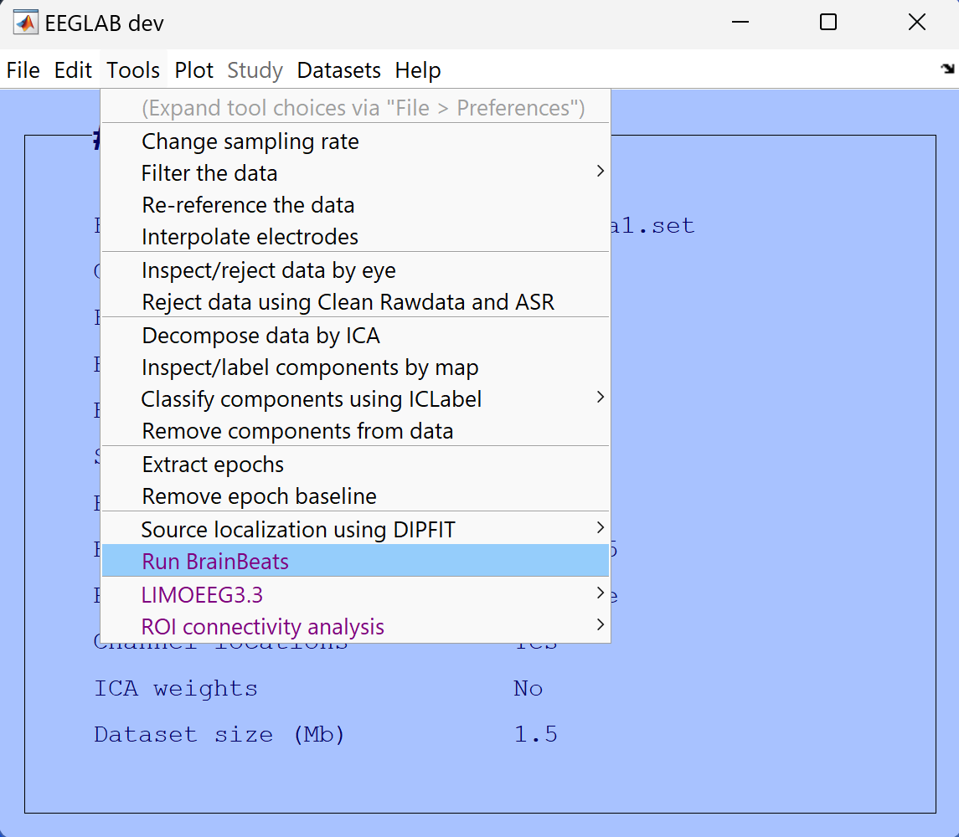

Figure 1. Launching the BrainBeats plugin from the mean EEGLAB menu.

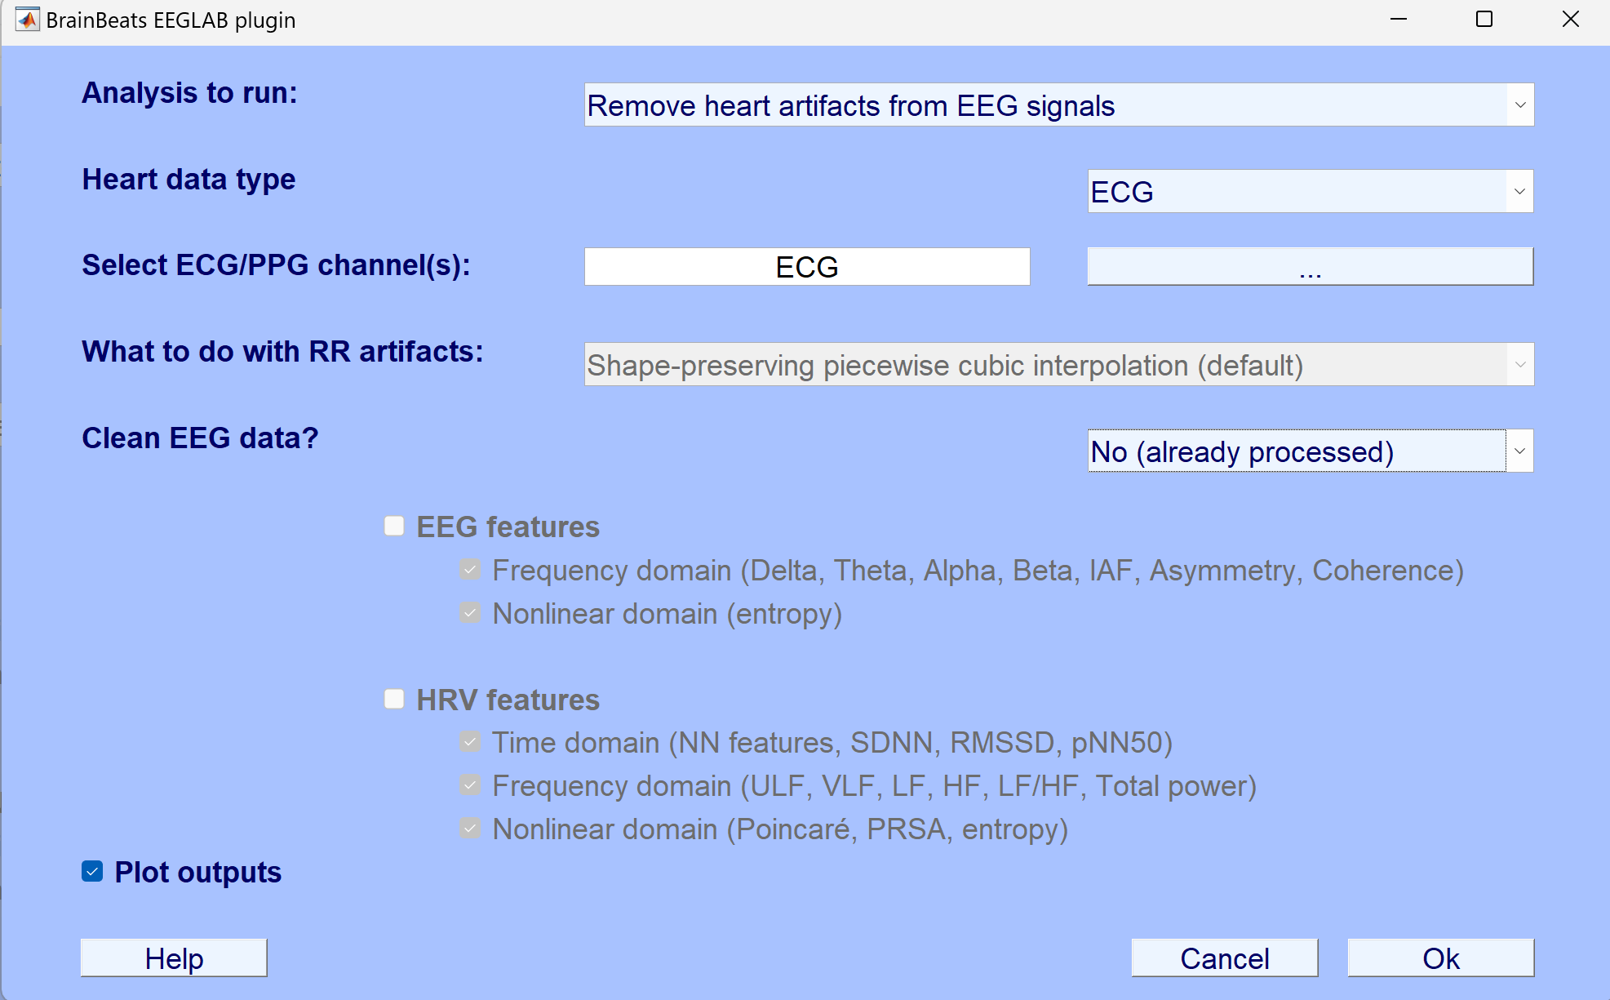

Figure 2. Selecting parameters from the general user interface (GUI).

1.4. Independent component analysis (ICA) runs (Infomax algorithm), using PCA reduction is the effective data rank is lower than the number of channels ([Ref](https://www.frontiersin.org/articles/10.3389/frsip.2023.1064138/full?&utm_source=Email_to_authors_&utm_medium=Email&utm_content=T1_11.5e1_author&utm_campaign=Email_publication&field=&journalName=Frontiers_in_Signal_Processing&id=1064138)), and the ICLabel plugin (Ref) is called to automatically detect heart components with at least 95% confidence. Note: the ECG channel(s) is kept, increasing ICA’s source separation performance and chances to separate heart components from the EEG signals, if present. See representative results below.

These steps can be run using the following command lines:

dataDir = fileparts(which('pop_BrainBeats.m'));

EEG = pop_loadset('filename','sample_data1.set','filepath',dataDir);

EEG = pop_BrainBeats(EEG,'analysis','rm_heart','heart_signal','ECG','heart_channels', {'ECG'},'vis',true);

**METHOD 2: Heartbeat-evoked potentials (HEP)**

2.1. Load data into EEGLAB: File > Load existing dataset > select “sample_data2.set

2.2. Tools > Run BrainBeats to select the following parameters: Click on “Heartbeat-evoked potentials HEP)” analysis to unlock the other parameters below; select the “EXG5” and “EXG6” ECG channels (click the button to display the list of channels, or type the channel names manually in the text box); You may leave the other default parameters. See overview in **Figure 3**.

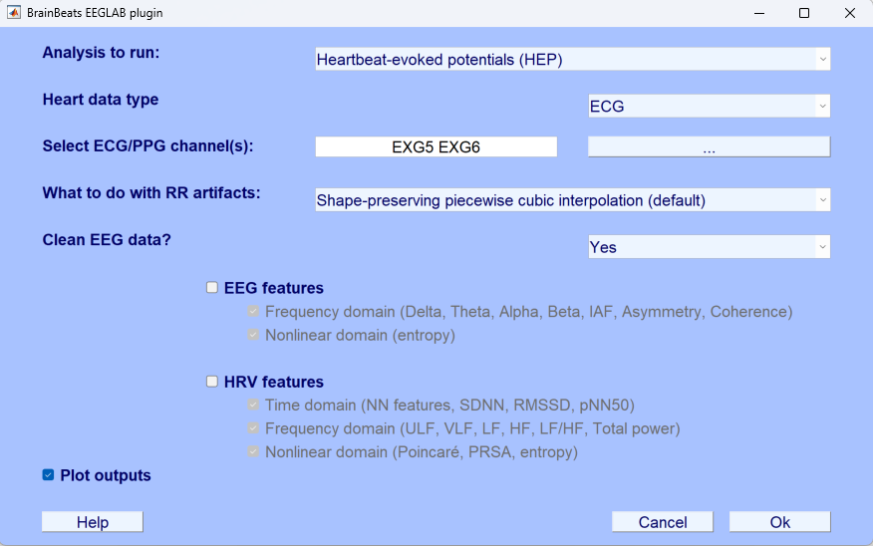

Figure 3. Selecting parameters from the GUI for performing heartbeat-evoked potentials (HEP) analysis.

* 1. By default, BrainBeats applies a zero-phase non-causal FIR filter to remove low-frequency drifts and high-frequency noise (high-pass cutoff frequency = 0.5 Hz, low-pass cutoff = 45; order = 846; transition bandwidth = 1 Hz). Then, BrainBeats uses the *clean_rawdata* plugin to remove bad EEG channels (ignoring the ECG channels) and interpolates them using EEGLAB’s spherical splines interpolation (Perrin et al., 1989).
  2. R peaks are detected using the P&T method. The energy threshold is estimated at 98-99% of the amplitude of the distribution to better deal with large bumps. A search back algorithm finds missed peaks by lowering the threshold in area where the RR interval variability is higher than 1.5 times the median. The algorithm also detects the polarity of the peaks (positive or negative). Refs: Behar et al (2014); Johnson et al. (Year).
  3. The signal quality index is calculated using the method developed by Vest et al. in the Physionet Cardiovascular Signal toolbox (Vest et al 2017).
  4. RR artifacts are interpolated.
  5. R peaks are marked as events in the EEG signals for segmentation.
  6. EEG data are segmented around the heartbeats, and the bad epochs are detected and removed. BrainBeats then performs source separation using infomax ICA (with PCA dimension-reduction when the data are rank-deficient; Kim et al. 2023) and removes ocular and muscular components classified by ICLabel with at least 95% confidence.
  7. Files are then saved with the same name as the original file with “_HEP” at the end, and are later imported in an EEGLAB STUDY to compute time-frequency.
  8. Statistical analyses are done using hierarchical linear modeling with the LIMO plugin.

**METHOD 3: Feature-based analysis from continuous data**

**REPRESENTATIVE RESULTS:** *(Example Representative Results section:* [*www.jove.com/52010*](http://www.jove.com/52010)*)*

Please provide a concise, written description of a representative outcome following the use of this protocol, so that a viewer will have a sense of a “positive” and/or “negative” result. **Please reference all data and figures in the manuscript**, emphasizing how the results confirm the success of the protocol, and how to interpret the data. Please include data from successful experiments, and data from sub-optimal experiments to demonstrate the range of outcomes possible. Also include results for possible outcomes if critical steps are not followed. A diagram/schematic of the method is recommended but is NOT sufficient.

All claims of the effectiveness of a method must be supported with data, *i.e.*, representative results. For example: If authors claim that method X cleanly purifies nuclear envelope proteins from a cell, they must include a figure definitively demonstrating this purification. The manuscript must include at least one figure or table providing Representative Results.

Provide a separate file for each figure and table; do NOT embed figures or tables within the manuscript document. The default placement for all figures and results tables in the final publication is below the Representative Results text. Please indicate, via brackets [Place Figure 1 here], if you prefer figure/table placement at another location in the text.

**If a figure is adapted or republished from a previous publication, authors must cite the original article in the figure legend. Reprint permission for the previously published/adapted figure is required upon acceptance.**

Example: This figure has been modified from [citation].1

**METHOD 1**

When no heart components are detected, users are informed in MATLAB’s command window and the program ends. If at least one heart component is detected, its scalp topography and confidence level are displayed in a figure (**Figure 3 Left**). Click on the red button to visualize the heart component’s detailed properties (**Figure 3 Middle**). Click “Ok” or exit buttons when done with visualization. The ECG channel is then removed from the dataset and the heart component is extracted from the EEG signals automatically. The difference between before and after heart component removal is displayed automatically (**Figure 3 Right**). Note: All figures are only created when the “Plot outputs” box is checked in the GUI).

Figure 3. Left: Scalp topography and confidence level of the heart component that was detected by ICLabel. Middle: Detailed properties of the component can be visualized by clicking on the red button on the Left. Right: Difference between before and after removal of the heart component from EEG signals. The ECG channel is then removed from the dataset.

**FIGURE AND TABLE LEGENDS:** Text: Use Calibri, 20 pt. font or greater.

* All figures should be provided as individual files. DO NOT embed them in the manuscript file.
* All microscopic images must include scale bars.
* All data figures must include measurement definitions and error bars (if applicable). Please define all error bars (SEM, SD, Range, *etc*.).
* Axis/Axis Tick Labels/Graph Lines: Use 20 pt. size font or greater, 3 pt. line weight or greater.
* A multi-panel figures (with parts A, B, C, *etc*.) should be submitted as a single, combined image file that contains all parts of the figure.
  + Preferred figure file types: .eps, .psd, .pdf. Please save any .ai files as a .pdf for submission but maintain .ai files for production purposes.
  + .tiff, and .jpg (not preferred) files must be at least 1,440 pixels x 480 pixels, or 300 dpi.
  + Preferred animated figure file types: .mov, .mp4, .m4v (upload as “Animated/Video Figure”).
  + 50 MB maximum size (Contact your editor or [submissions@jove.com](mailto:submissions@jove.com) for exceptions).
  + All tables should be provided as individual .xls or .xlsx files and submitted as Tables.

**TABLE OF MATERIALS:** A Table of Materials is required for all articles. A template is provided [here](http://www.jove.com/files/templates/JoVE_Materials.xls). Please do not number the Table of Materials in the article. Please do not include any ™/®/© symbols here.

**FIGURE AND TABLE LEGENDS:**Each figure or table, including supplemental figures/tables, must have an accompanying legend comprised of a short title and a short description of each panel or a general description. Legends should be included as part of the manuscript and not included in the figure file.

Example: **Figure 1:** **Representative flow cytometry analysis of non-permeabilized cells**. **A**. Schematic representation of gating strategy used in flow cytometry analysis sample. Data were analyzed after acquisition with the appropriate software… **B**.Semi-log graph for the….

Enter text here.

**DISCUSSION:** *(3-6 paragraphs)*

JoVE is a methods-based journal. Thus, the Discussion section of the article should be focused on the protocol and not the representative results. This section should discuss the following with citations:

* Critical steps in the protocol
* Modifications and troubleshooting of the method
* Limitations of the method
* The significance of the method with respect to existing/alternative methods
* Future applications or directions of the method

Entropy features are particularly promising for capturing complex, bidirectional interactions between cardiovascular, subcortical, and cortical systems that may be hidden in nonlinear feedback loop dynamics (Costa et al., 2005).

**ACKNOWLEDGMENTS:** Please list acknowledgments and all funding sources for the work here. Also consider listing any person appearing in the film who does not appear in the authors list.

Add the Time-Resolved Directional Brain-Heart Interplay Measurement Through Synthetic Data Generation Models: <https://pubmed.ncbi.nlm.nih.gov/30989444/>

**DISCLOSURES:** The corresponding author must ensure that all authors have disclosed any and all conflicts of interest. Examples of a conflict of interest would be “The author [full name] is an [employee/shareholder, *etc.*] of [full company name] that produces reagents and/or instruments used in this Article”. If authors have no conflict of interest, a statement stating this must be included. The default text is “The authors have nothing to disclose.”

Enter text here.

**REFERENCES:** *(10 minimum; if using EndNote, please use the* [*JoVE EndNote style file*](http://www.jove.com/files/JoVE.ens)*)*

In-Text Formatting:

* The corresponding reference numbers should appear as superscripts after the appropriate statement(s) in the text (before punctuation but after closed parenthesis). The references should be numbered in order of appearance.
* Multiple references should be separated by commas, or a dash for inclusive numbers: example2,5 refers to references 2 and 5, while example2-5 refers to references 2 through 5.
* Personal communications, unpublished data, and conference abstracts can be cited parenthetically in the text with author last name, initials, and year.
* Footnotes should not be used. Grant details and personal acknowledgments should not be cited as a numbered reference (but included in the Acknowledgments section).

*Citation Formatting:* (in order)

* Last name, first and middle initials (if available). List ALL authors. If there are six or more authors, list the first author and then “*et al.”*.
* Include article, book, or chapter titles. Titles of books should be italicized, whereas article and chapter titles should not.
* Article titles should start with capital letters and end with periods, and should appear exactly as they were published in the original work with no abbreviations or truncations.
* Write journal names in italics. The city or country where a journal is located can be included in parenthesis with the journal name. For books or other works, a publisher name, city, and country can be included.
* Write volume numbers in bold, followed by a space, issue number (in parentheses), a comma, and then a range of page numbers (start page – last page). A single page number or digital object identifier [doi] can be substituted for a range of page numbers.
* Provide the year published (in parentheses), followed by a period.
* “Accepted” or “In Press” can be listed after the title or journal name and before the year. Manuscripts that are in preparation or under review should not be listed.

*Citation Examples:*

Bedford, C.D., Harris, R.N., Howd, R.A., Goff, D.A., Koolpe, G.A. Quaternary salts of 2-[(hydroxyimino)methyl]imidazole. *Journal of Medicinal Chemistry*. **32** (2), 493-503 (1998).

Kioh, L.G. *et al.* *Physical Treatment in Psychiatry*. Blackwell Scientific Pubs. Boston (1988).

von Bertalanffy, L. (1968). General system theory: Foundations, development, applications. George Braziller.

Bunge, M. (2003). Emergence and convergence: Qualitative novelty and the unity of knowledge. University of Toronto Press.

Fuchs, T. (2018). Ecology of the brain: The phenomenology and biology of the embodied mind. Oxford University Press.

Thayer, J. F., & Lane, R. D. (2009). Claude Bernard and the heart-brain connection: Further elaboration of a model of neurovisceral integration. Neuroscience and Biobehavioral Reviews, 33(2), 81-88.

Insel, T. R., Landis, S. C., & Collins, F. S. (2017). Research priorities. The NIH BRAIN Initiative. Science, 340(6133), 687-688.

Kappenman, E. S., & Luck, S. J. (Eds.). (2010). The Oxford handbook of event-related potential components. Oxford University Press.

Costa, M., Goldberger, A. L., & Peng, C. K. (2005). Multiscale entropy analysis of complex physiologic time series. Physical Review Letters, 89(6), 068102.

Kemp, A. H., Quintana, D. S., Gray, M. A., Felmingham, K. L., Brown, K., & Gatt, J. M. (2010). Impact of depression and antidepressant treatment on heart rate variability: A review and meta-analysis. Biological Psychiatry, 67(11), 1067-1074.

Lehrer, P., Gevirtz, R., & Eddie, D. (2021). Heart rate variability biofeedback: A theoretical perspective and review of its effectiveness for

Bean, B. P., Cohen, C. J., & Tsien, R. W. (1984). Lidocaine block of cardiac sodium channels. The Journal of General Physiology, 73(6), 679-696.

Thayer, J. F., Åhs, F., Fredrikson, M., Sollers III, J. J., & Wager, T. D. (2012). A meta-analysis of heart rate variability and neuroimaging studies: Implications for heart rate variability as a marker of stress and health. Neuroscience & Biobehavioral Reviews, 36(2), 747-756.

Mather, M., & Thayer, J. F. (2018). How heart rate variability affects emotion regulation brain networks. Current Opinion in Behavioral Sciences, 19, 98-104.

Kemp, A. H., & Quintana, D. S. (2013). The relationship between mental and physical health: Insights from the study of heart rate variability. International Journal of Psychophysiology, 89(3), 288-296.

Jiang, H., He, B., Guo, X., Wang, X., Guo, M., Wang, Z., ... & Cui, D. (2020). Brain–Heart interactions underlying traditional Tibetan Buddhist meditation. *Cerebral Cortex*, *30*(2), 439-450.

Schandry, R. (1981). Heart beat perception and emotional experience. Psychophysiology, 18(4), 483-488.

Pollatos, O., Kirsch, W., & Schandry, R. (2005). Brain structures involved in interoceptive awareness and cardioafferent signal processing: a dipole source localization study. Human Brain Mapping, 26(1), 54-64.

Montoya, P., Schandry, R., & Müller, A. (1993). Heartbeat evoked potentials (HEP): topography and influence of cardiac awareness and focus of attention. Electroencephalography and Clinical Neurophysiology, 88(2), 163-172.

Park, H. D., & Tallon-Baudry, C. (2014). The neural subjective frame: from bodily signals to perceptual consciousness. Philosophical Transactions of the Royal Society B: Biological Sciences, 369(1641), 20130208.

Couto, B., Adolfi, F., Sedeño, L., Salles, A., Canales-Johnson, A., Alvarez-Abut, P., ... & Ibanez, A. (2015). Disentangling interoception: insights from focal strokes affecting the perception of external and internal milieus. Frontiers in Psychology, 6, 503.